Return to Educational Facility

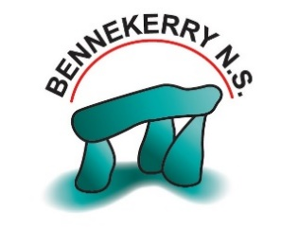
Parental Declaration Form

Bennekerry N.S.

Child’s Name: | Principal’s Name: Tonia Cleary
Parents/Guardian’s Name:

Name of Setting: Bennekerry N.S., Carlow

This form is to be used when children are returning to the setting after any absence.
Declaration:
I have no reason to believe that my child has infectious disease and I have followed all medical and public health guidance with respect to exclusion of my child from educational facilities.

Signed Date:

